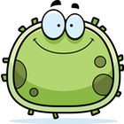**Cells Lab**

**Part 1: The Human Cheek Cell**

Name:_________________________

1. Describe or define each of the following:

cell membrane _________________________________________________________________

cytoplasm _______________________________________________________________________

nucleus ________________________________________________________________________  
  
organelle ________________________________________________________________________

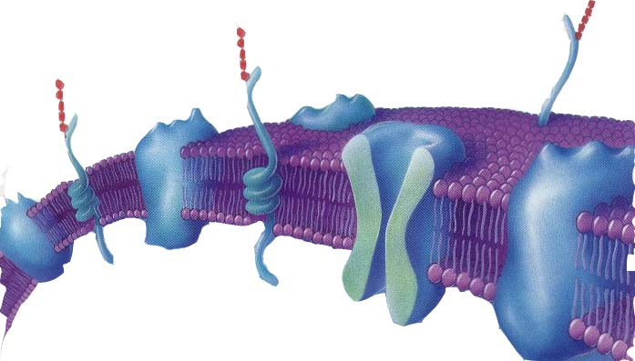

3

2

1

2. What are the three structures found within the

cell membrane (picture on the right) and what do they do?

**Procedure:**

1. Put a drop of methylene blue on a slide. Caution: methylene blue will stain clothes and skin.

2. Gently scrape the inside of your cheek with the flat side of a toothpick. Scrape lightly.

3. Stir the end of the toothpick in the stain and throw the toothpick away.

4. Place a coverslip onto the slide

5. Using low power, focus on the specimen. Cells should be visible, but they will be small and look like nearly clear purplish blobs. If you are looking at something very dark purple, it is probably not a cell.

6. Once you think you have located a cell, switch to medium, then high power and refocus.

|  |  |
| --- | --- |
| **Structure** | **Function** |
| 1. |  |
| 2. |  |
| 3. |  |

3. Sketch the cheek cell under low power and again under high power. **Label the nucleus, cytoplasm, and cell membrane.**

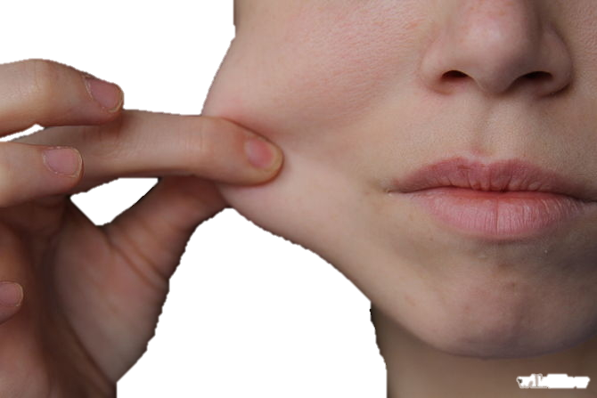

Low Power

High Power

4. Why is adding methylene blue to the slide necessary?

5. Is the cheek cell a eukaryote or prokaryote? How do you know?

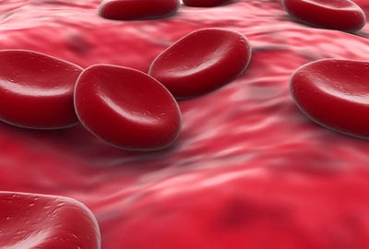

**Part 2: Blood Cells**

Procedure: Obtain a prepared slide of frog blood. Focus on the slide under low power, then medium and finally high power.

Compare and contrast your cheek cell with the blood cell.

**Similar Different**

Sketch the blood cells under high power. Label any visible organelles.

1. Humans can be blood type A, B, AB or O. If an injured patient is in need of a blood transfusion, they must be matched with someone with the same blood type or else the patient’s body will reject the donor blood. What protein is responsible for this?
2. Why would your identical twin be the most successful match for an organ transplant?

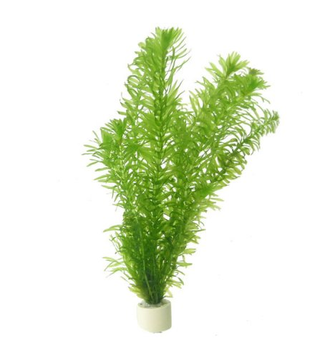

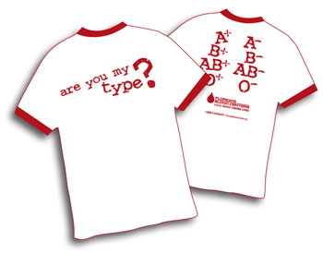

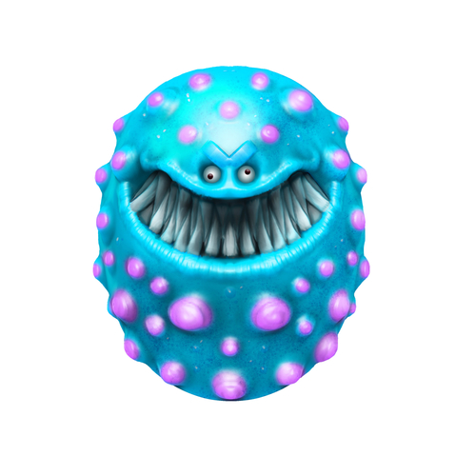

**Part 3: Bacteria Cells**

Procedure: Take a prepared slide of bacteria cells. You will need to find them under high power. Sketch the bacteria cells under high power and label any organelles you are able to see.

1. How do the size of bacteria cells compare to the size of your cheek cells?
2. Are bacteria prokaryotes or eukaryotes?
3. If we had a microscope that went to a higher magnification, which organelles might you be able to see inside of the bacteria?
4. How does your immune system distinguish between your own cells and bacteria cells?

**Procedure:**

1. Prepare a wet-mount slide of an Elodea leaf. Observe the thick cell wall, thinner cell membrane, cytoplasm, nucleus, and chloroplasts. A large central vacuole may be apparent. These structures characterize a generalized plant cell.

2. Prepare a wet-mount slide of onion tissue. Onions have layers of modified leaves that can easily be separated from one another. Peel off a portion of one layer and examine the concave side of the piece you have obtained. The surface is covered by a thin layer of cells, the epidermis.

Part 4: Plant Cells

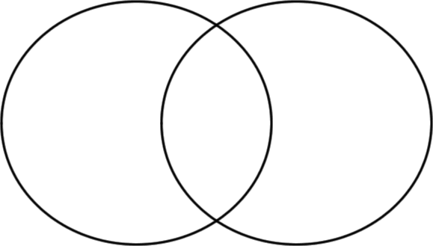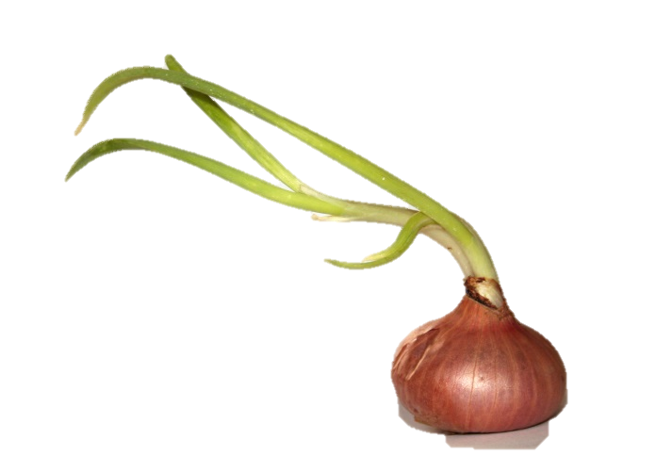

1. What is the function of chloroplasts?

2. Name two structures found in plant cells but not animal cells.

3. Name three structures found in plant cells AND in animal cells.

4. What structure surrounds the cell membrane (in plants) and gives the cell support.

5. Why were no chloroplasts found in the onion cells? (hint: think about where you find onions)

6. Fill out the Venn Diagram below to show the differences and similarities between the onion cells and the elodea cells.

**Part B - Elodea Cells**

View an elodea under the microscope. Sketch and label the cells at high power. Include: cell wall, nucleus, and cytoplasm.

**Part A - Onion Cells**

View an onion under the microscope. Sketch and label the cells at high power. Include: cell wall, nucleus, and cytoplasm.

**Post Lab Questions**

1. What is the function of chloroplasts?

