Element | Symbol | % in the Body
Oxygen | O | 65
Carbon | C | 18.5
Hydrogen | H | 9.5
Nitrogen | N | 3.2
Calcium | Ca | 1.5
Phosphorus | P | 1
Potassium | K | .4
Sulfur | S | .3
Sodium | Na | .2
Chlorine | Cl | .2
Magnesium | Mg | .1
Trace elements include Boron (B), Chromium (Cr), Cobalt (Co), Copper (Cu), Fluorine (F), Iodine (I), Iron (Fe), Manganese (Mn), Molybdenum (Mo), Selenium (Se), Silicon (Si), Tin (Sn), Vanadium (V), and Zinc (Zn) |  | Less than 1.0
"201 Elements of the Human Body-01" by OpenStax College - Anatomy & Physiology, Connexions
Human Body
Elements of the

Name______________________
Use the table on the right to make a bar graph of the percentage of each element found in the human body. Then answer the questions below. You DO NOT have to graph the trace elements listed in the last row on the table.
- As you graph, leave a space between each element, instead of a legend, simply label each element underneath it’s bar.
- The Independent variable belongs on the X axis, so place

_________________on the X axis
- The Dependent variable belongs on the Y axis, so place

_________________ on the Y axis
- Use what you wrote above to label each axis of the graph and also give the graph a title.
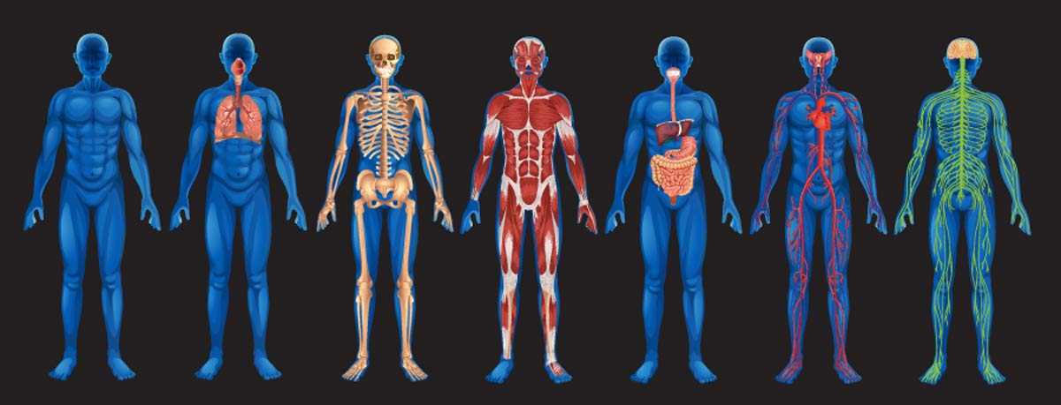
- As you graph map simply skip a space between each element on the Y axis.

1. Which element is the most common in our body & what percentage does it make up?

2. Which element is found in ALL organic molecules & what percentage does it make up?

3. What are the 6 most common elements in ALL living things?

4. Which of the 6 most common elements in ALL living things is missing from the 6 that are most common in the human body?
Is this element still found in the human body?
5. Which of the 6 most common elements in the human body is not on our list of the 6 that are most common elements in ALL living?
6. What do you think is the reason this element is so common in the human body, but not in ALL organisms? (*Think about what structures in your body need this element.)

