Name_____________________
Macromolecules CLab
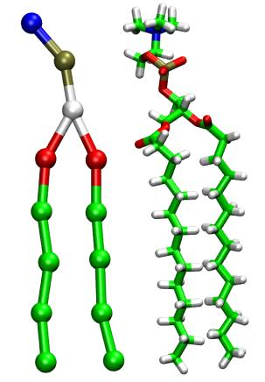
https://goo.gl/wu77US Which macromolecule am I? Write the macromolecule that each person is representing on his shirt.
I am useful for a fast source of energy.

I have a large role in the immune system (example: antibodies).
I am helpful for long term energy storage.
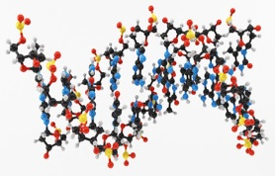
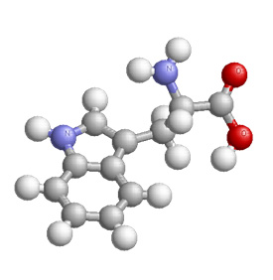
Enzymes, which can speed up reactions, belong in my category.

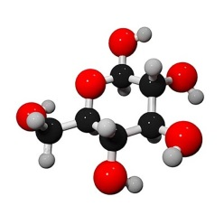

A mutation in DNA would initially start with me.

I have a large role in muscle development.

Name_____________________
Macromolecules CLab
https://goo.gl/wu77US Which macromolecule am I? Write the macromolecule that each person is representing on his shirt.
I am useful for a fast source of energy.

I have a large role in the immune system (example: antibodies).
I am helpful for long term energy storage.
Enzymes, which can speed up reactions, belong in my category.

A mutation in DNA would initially start with me.

I have a large role in muscle development.

Biomolecule/  Macromolecule | Makes Me Think Of…  (this can be original for you) | Monomer  (Building Block) | Elements | Example
Carbohydrate
Lipid
Protein
Nucleic Acid

Biomolecule/  Macromolecule | Makes Me Think Of…  (this can be original for you) | Monomer  (Building Block) | Elements | Example
Carbohydrate
Lipid
Protein
Nucleic Acid

