Mix and Match Ecology: Symbiosis

Choose two imaginary organisms, and decide for one or both to have a need. Determine the niche of each organism, describe how a symbiotic relationship between the two meets the needs and tell which type of symbiosis it is. Get creative! You must invent extra information in order for each relationship to make sense. You will need to draw what your organisms look like and demonstrate the type of symbiosis on the attached piece of paper.

IMANINARY ORGANISM
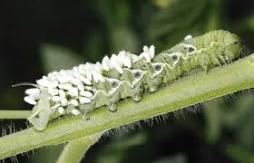
-Cratz
-Gimflobby
-Lunic
-Majooka
-Scuzit
-Elladock
-Thustle
-Jory
-Gollyper
-Zumble
-Coblatty
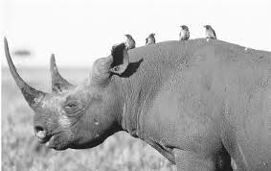
-Blubussle
-Plonk
-Invent your own?

ORGANISM’S NEED
- A pollinator to help with reproduction
-A very dark environment
-Help digesting its food
-Lots of sun exposure
-Protection from herbivores
-Slime to lay eggs in
-It’s eye to be cleaned
-A deep hole to live in
-Blood for food
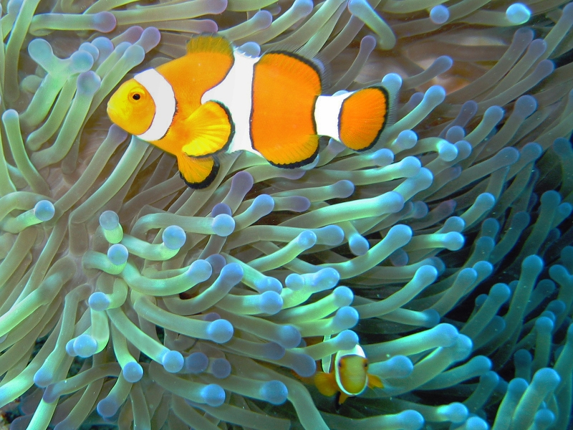
-A home inside a warm moist place
-A way to move around

TYPE OF SYMBIOSIS
-Mutualism
-Commensalism
-Parasitism

Name____________________________________ Period________________

Mix and Match Ecology: Symbiosis

Name of organisms:

Niche they belong to:

Their symbiotic relationship (GIVE ME DETAIL!):

Which type of symbiosis is this?:

Additional Information about this relationship:

Picture of your symbiotic relationship-Use color!

