Test Crosses: Dominant vs Recessive Traits
Names__________________________
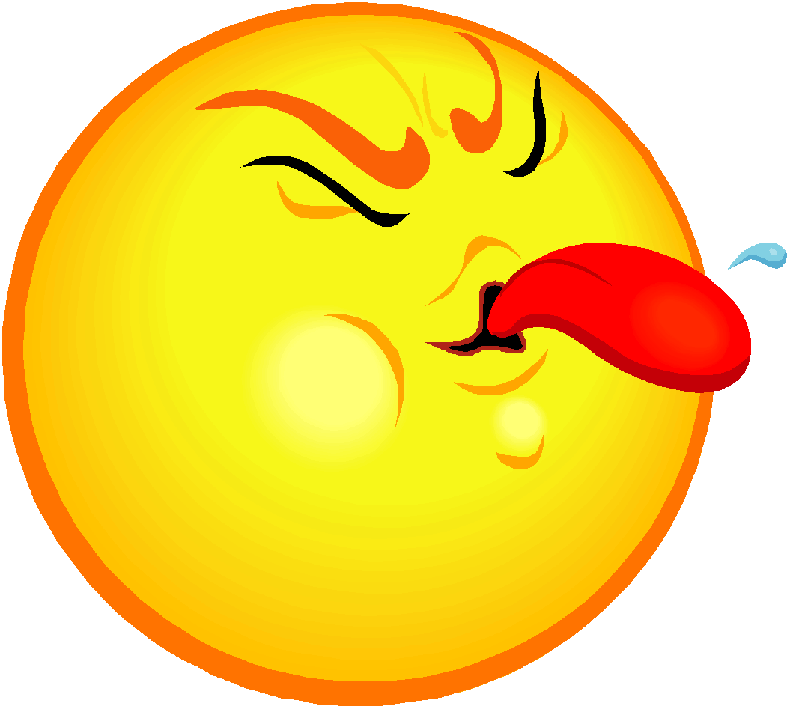
1. Tongue rollers vs. non-rollers: If you are able to roll your tongue into a U-shape, you are a roller (R). If you cannot roll your tongue, you have two non-roller (r) alleles.
Partners’ Names | Phenotype | Genotype(s)
Question: If you and your partner were siblings, what genotypes might your parents have had? List all possible combinations!

Partners’ Names | Phenotype | Genotype(s)
2. Widow’s peak vs. Straight hairline: If you have a pointed hairline forming a “W”, you have the dominant allele for widow’s peak (W). If you have a straight hairline, you are homozygous recessive.

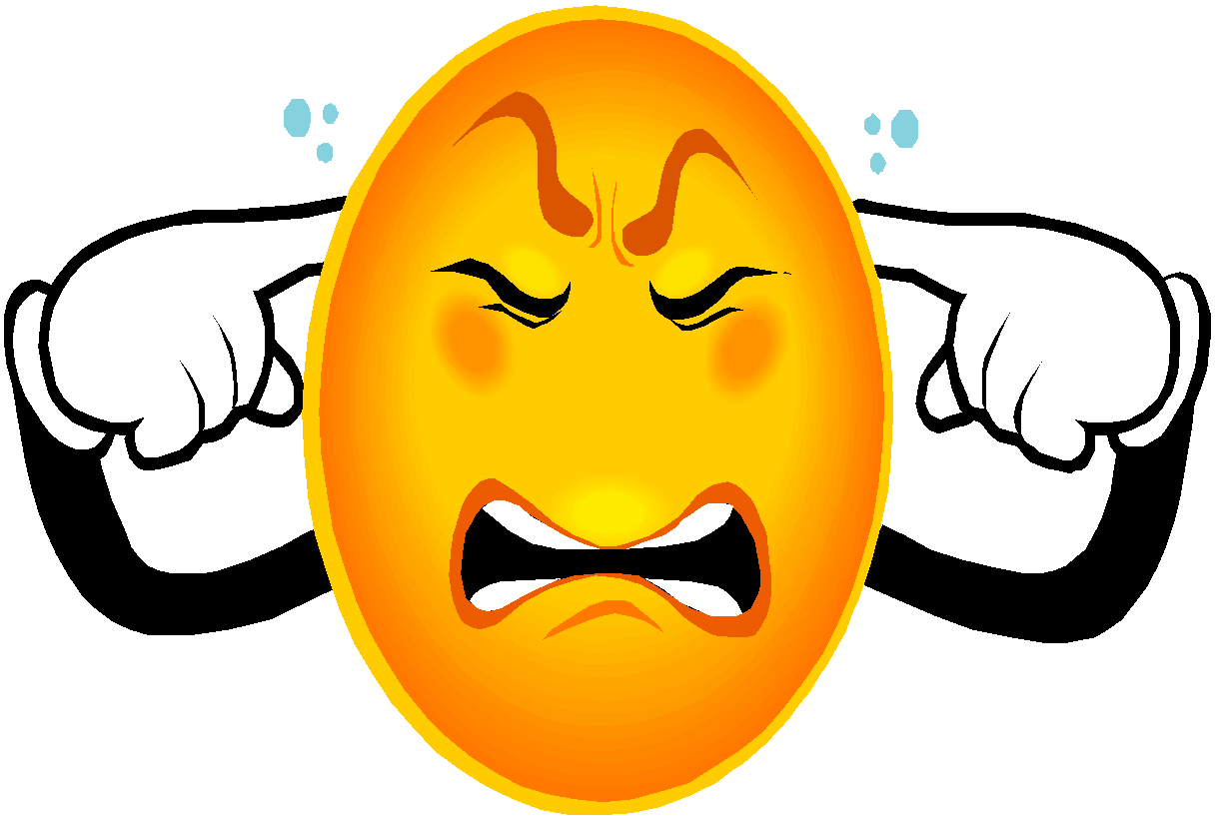
3. Attached vs. free earlobes: If your earlobes are even partially detached from the side of your face, you have the dominant allele for free earlobes (E). If your earlobes are completely attached, you are homozygous recessive for this trait.
Partners’ Names | Phenotype | Genotype(s)
Question: Both of your parents and your four sisters have free earlobes, but
you have attached ones. What are the genotypes of your parents?

4. Bent vs. Straight Little Fingers: If the end of your pinky finger bends at the top when your hands are held together, you have at least one “F”.
Partners’ Names | Phenotype | Genotype(s)
Question: You were born with a straight finger, but you broke the end joint on your pinky finger in a snowboarding accident last year. This caused your little finger to become bent. What genotype/phenotype do you have now? Can you pass this trait on to your children?

5. Hitchhiker’s vs. Straight thumb: If the last part of your thumb bends at an angle of at least 45 degrees when you make a hitchhiker’s sign, you carry the dominant allele (H).
Partners’ Names | Phenotype | Genotype(s)
Question: Baby does NOT have a hitchhiker’s thumb, but his dad, Jack and his mom, Jill, both have it. What are the chances that Jack and Jill’s next child WILL have a hitchhiker’s thumb? Show a Punnett square.

Partners’ Names | Phenotype | Genotype(s)
6. Mid-digit Hair: Each finger on your hands has three segments. If any hair is present on the middle segments, you have the dominant allele for mid-digit hair (D). If not, you are homozygous recessive (dd).

7. Dimpled vs. no dimpled chin: A dimpled chin is caused by the dominant allele (D).
Partners’ Names | Phenotype | Genotype(s)
Question: A couple wants to have a baby. What are their chances of having a “butt chin” baby if the mom doesn’t have a dimpled chin but the dad does? Show how.

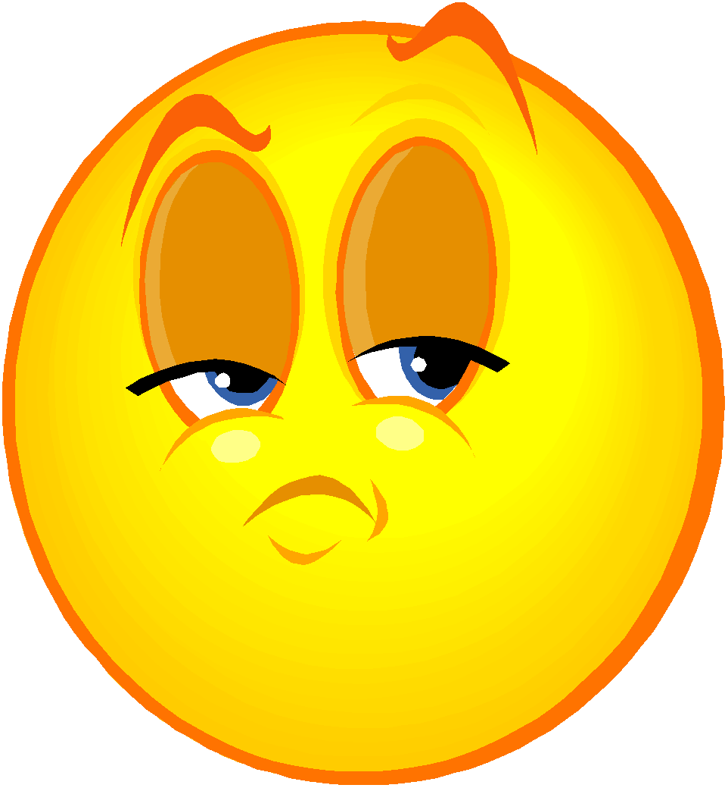
8. Interlacing fingers: Casually fold your hands in front of you. Now look at your hands. If your left thumb is on top, you possess the dominant allele (T). If your right thumb is on top, you are homozygous recessive. (Move your hands apart and try to switch. Weird, huh? Try the same thing with folding your arms.)
Partners’ Names | Phenotype | Genotype(s)
Question: Can two “right thumbers” ever give birth to a “left thumber”? Show what you mean with a Punnett Square.

