That Magical Moment

Background: Chromosomes are composed of DNA and contain the genetic blueprint for an organism. Each species has its own unique set of chromosomes. Humans have 46, dogs have 78, a cat has 38, and the mouse it chases has 40. Within each individual in a species, every somatic cell contains the same number of chromosomes as every other. Humans are diploid organisms meaning that each cell contains two complete chromosome sets. Answer the background questions before proceeding to the rest of the lab.

Materials: paper, pen/pencil, clay
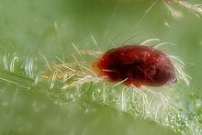
Part One: The Process of Meiosis
You are going to work through the genetic events involved in meiosis--the process of cell division that creates sex cells/gametes/egg or sperm. You will be working with the chromosomes of a spider mite.
Follow the instructions through one time, answering the questions as you go.

Set Up:
- Place a sheet of notebook paper in the center of your work space. This will represent the parent cell. (Q1) If this was happening in humans, in what two places in the body could you be?

- You are now going to create a diploid cell containing two pair of chromosomes. Using a piece of clay and your expert snake-making skills, create two large snakes and two small snakes. These represent the chromatid before the cell completes interphase.
- During interphase, the cell grows and replicates the DNA. Represent this by creating an exact copy of your 2 large chromatids, and 2 small chromatids already located in the cell. Connect the replica/copy to the original to make 2 large X and 2 small X-shaped chromosomes.
(Q2) What happens during Interphase, and how did it change the chromatid?
- Set your newly made two pairs of homologous chromosomes randomly inside the cell. On one of the larger X’s, use a toothpick to make candy-cane like stripes on the chromosome. Make dots on one of the smaller X chromosomes.

Procedure:
Prophase I
- Pair up each newly made replicated chromosome with it homologous pair. (Q3) What does homologous mean?
- Now that the homologous pairs are close to each other, crossing over can occur. Model this process by breaking off a piece of clay from one of the chromosomes and switching it with a piece of the same size, as the picture below shows. (Q4) Sketch your homologous chromosomes before crossing over and after crossing over.
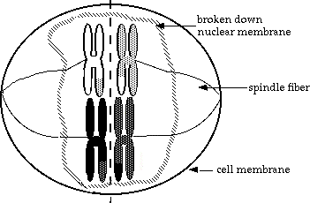
Metaphase I
- (Q5) Where do chromosomes line up in Metaphase?
- Spindle fibers would attach to the centromeres of each chromosome to direct movement. Your hands will serve as the spindle fibers today. ☺
Anaphase I
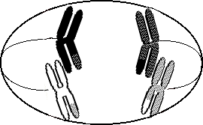
- Move the homologous pairs AWAY from each other.

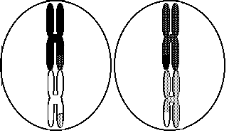

Telophase I/Cytokinesis
- Rip your cell/paper into 2 smaller cells to represent the splitting of the cytoplasm.

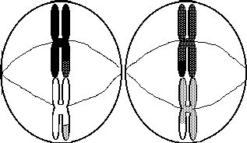
(Q6) How many chromosomes did you start with in the first big cell? How many chromosomes does each smaller cell now have? Circle either diploid or haploid to label each number.

Prophase II and Metaphase II
- Line up the chromosomes in each cell end to end along the center of the cell.
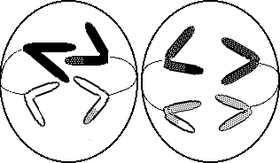
Anaphase II
- Separate the two sister chromatids as shown. (Q7)How is Anaphase II different than Anaphase I?

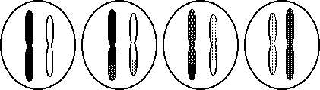
Telophase II and Cytokinesis
- Cut your two cells into two more, making sure that each new, smaller cells just one copy of the two chromosomes. Your final product should look like the diagram below.

Once you have successfully completed meiosis, show your teacher the final product. Great job! Once you have filled in the chart and handed in your questions, you may mush up all your chromosomes into one ball and proceed with Part Two.

Part Two: Meiosis Magic
Set Up for Females:
- Take your ball of clay and instead of just being DNA, now the clay represents an entire cell. As a parent sex cell in a female, this cell is full of nutrients to nourish a developing embryo. This cell would go through meiosis, just like you modeled earlier, but with a few twists.
- Unequally divide the female cell into one small cell and one large cell.
- Do this one more time. The small cell divides into two even smaller cells, and the large cell divides unequally into one large and one small.
- This unequal division of cytoplasm produces three non-functional polar bodies and just one large functional egg.

Set up for Males:
- Take your ball of clay and instead of just being DNA, now the clay represents an entire cell. As a parent sex cell in a male, this cell will have to swim inside the female’s body and race to reach the egg first. This cell would go through meiosis, just like you modeled earlier, but with a few twists.
- Start with the original ball of clay and divide that cell into two equal parts. Now do that again so you have a total of four equal cells.
- Each make gamete then grows a tail, so form a tail on each cell. Now the sperm are ready to “just keep swimming.”
*An interesting difference between the genders is that a baby girl is born with all the possible eggs she could ever produce in her ovaries. Typically, one egg matures and is released each month after puberty begins. In contrast, beginning at puberty males produce sperm cells in the testes continuously.

Part Three: That Magical Moment…Fertilization
- The union of the two gametes, egg and sperm, must take place in the female’s Fallopian tubes. Model this process with whichever gamete you made.
- The gametes were both haploid and now the newly formed zygote is diploid. The fertilized egg will keep traveling down the Fallopian tubes until it reaches the uterus. It then implants into the lining of the uterus and grows for nine months.
- Ta Da! The End. When finished, place all your clay back in the container, clean up your lab table, and hand in the instruction sheet.

