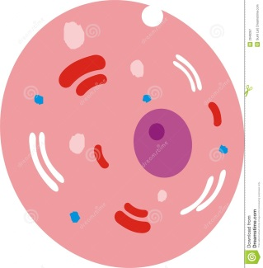
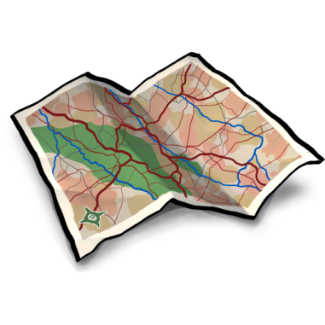
Travel Brochure for a Cell
Name________________________________________
Expectations:
Produce a travel brochure to attract visitors to spend money to visit an animal or plant cell. Think about your cell as a town, amusement park, small roadside attraction or school (or something original).
The brochure must accurately describe at least 8 “attractions, buildings, businesses” (organelles or cell processes) that will “delight and amaze” potential visitors. You can choose to create this brochure on a google document or on poster board materials. Ms. Hamann will have some supplies for you.
Be Creative!
Please name your town/park/school and include pictures of the “attractions/buildings” that represent your organelles (DO NOT draw me pictures of what the cell organelles look like—draw the analogies).
Examples:
“Stop in and visit our newly remodeled City Hall (Nucleus), where all the decisions about running our wonderful town are thought up.” “No need to worry about power outages with our new state-of-the-art fission power plant (mitochondria).”
Grading:
- Accuracy in describing functions of organelles (attractions/buildings)
- Use of at least 8 organelles
- Creativity and Design

List of Organelles:
- Plasma (cell) membrane 10. Lysosomes
- Cytoplasm 12. Ribosomes
- Nucleus 13. Cell Wall (Plant Cell Only!)
- Nucleolus
- Nuclear Membrane
- Endoplasmic Reticulum
- Mitochondria
- Chloroplasts
- Vacuole
- Golgi Apparatus
Grading Criteria

24 points: Use of 8 organelles
(3 points per organelle-1 for organelle, 2 for correct function)
(2 points for each organelle over 8)

10 points: Creativity
Use of your own ideas
Use of other materials (computer, magazines, pictures almost anything)

6 points: Design
Color/Pictures (3 points)
Neatness/Well done
_________________________________________________________
44 points total (Plus Extra Credit)

List of Organelles:
- Plasma (cell) membrane
- Cytoplasm
- Nucleus
- Endoplasmic Reticulum
- Mitochondria
- Chloroplasts
- Vacuole
- Golgi Apparatus
- Lysosomes
- Ribosomes
- Cell Wall (Plant Cell)

